The Response of First-Order Systems—Lab 9

M.V. Iordache, EEGR2051 Circuits and Measurements Lab, Fall 2020, LeTourneau University

See https://mviordache.name/EEGR2051 for more information.

Name______________________ Date__________ Section_____

EEGR 2051 –The Response of First-Order Systems. Thermal Circuits.

Materials
- One NI Elvis or one NI SC2075.
- Two 10kΩ resistors.
- One Darlington npn transistor MJE800 and one npn transistor MJE340.
- One heat sink.
- Wire jumpers.

Procedure

- Measure the two resistors. Resistor 1 has _________ and resistor 2 has _________.
- This experiment will illustrate the first order response on a thermal system consisting of two transistors connected to the same heat sink.
  - The Darlington transistor MJE800 will act as the heat source.
  - The transistor MJE340 will act as a temperature sensor.
- The transistors will be connected to the heat sink using binder clips.
  - The metal side of each transistor should face the heat sink.
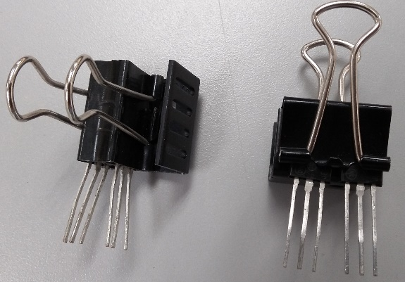
  - For a reasonably low thermal resistance, the components should fit tightly, without any space between the transistors and the heat sink.
  - Two possible ways of connecting the transistors to the heat sink are shown in the picture.
- Connect the transistors to the prototyping board.
- Attach heat sink.
- To avoid short-circuits, verify that the heat sink does not touch any terminals.
- Turn on the DC power supply and adjust it for:
  - 5 V voltage limit.
  - 1.5 A current limit.
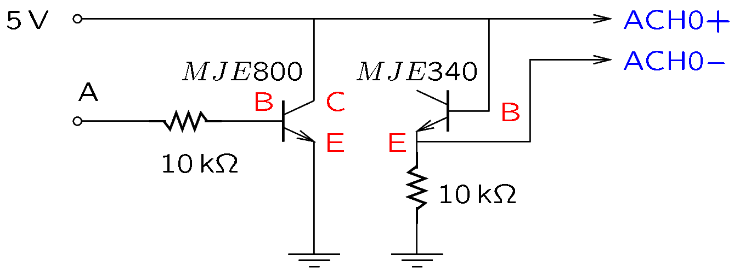
- Connect the circuit shown in the figure.
metal side
  - Transistors have three terminals B, C, and E, standing for base, emitter, and collector.
  - Use the DC power supply for the 5 V source. Do not use the DC source of the DAQ board, which has a low current limit!
  - Connect the negative terminal of the DC power supply to the GND of NI Elvis or NI SC2705.
  - Leave point A disconnected.
  - Leave the collector of MJE340 disconnected, as shown in the schematics. Connect only the points B and E of MJE340.
  - ACH0+ and ACH0- denote the terminals of the analog channel 0 of NI Elvis and NI SC2705.
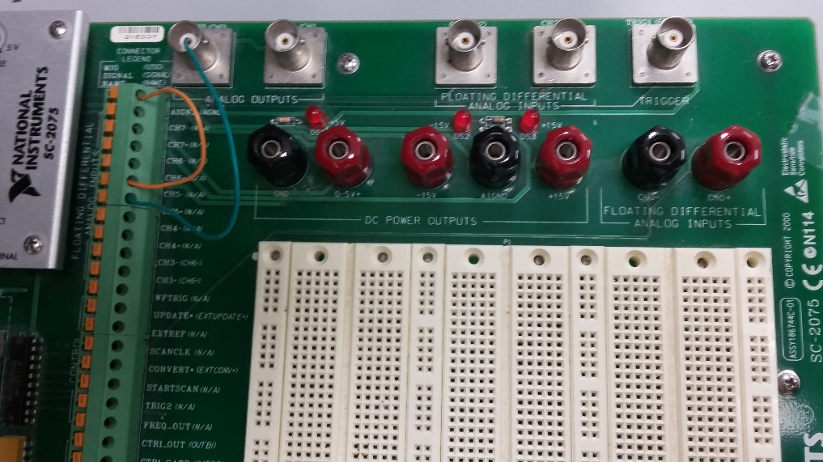
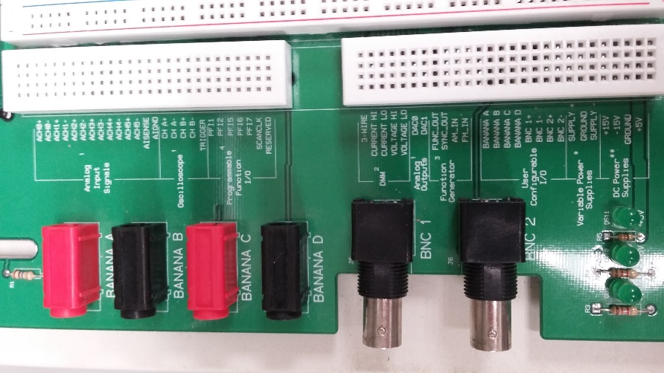
  - In this exercise, high current pulses will be applied to the heat element (MJE800). Since conductors are not ideal, a small pulsating voltage will appear on the conductors that power the heat element. This can interfere with the temperature sensor readings. (This phenomenon is known as conductive coupling interference.) To minimize interference:
ACH0
NI ELVIS
NI SC2075
    - Avoid sharing conductors between the heat source (MJE800) and the sensor (MJE340). The currents of the heat source and the sensor should flow on different paths to/from the 5V source.
    - Connect ACH0+ to the B terminal of MJE340.

- Create a virtual instrument (VI) for data acquisition and data logging.
  - Begin by adding the DAQ Assistant from the Express/Input menu of the block diagram.
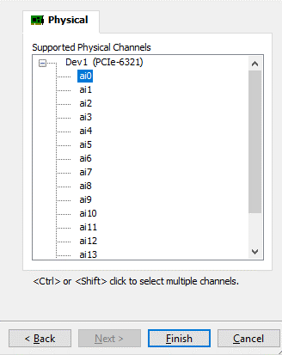
    - In the dialog box select Acquire Signals/Analog Input/Voltage/Dev1/ai0 and then Finish.
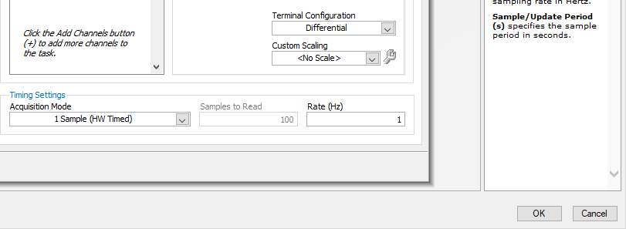
    - Select 1 Sample HW Timed for the Acquisition mode, a 1 Hz rate, and differential configuration and press OK.
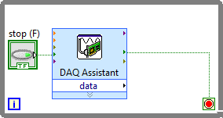
    - Select Yes in the next dialog box to set up a loop for the DAQ Assistant.
    - At this point the block diagram should look as shown in the figure.

  - Add a numerical indicator to the front panel.
  - Add also a waveform chart to the front panel.
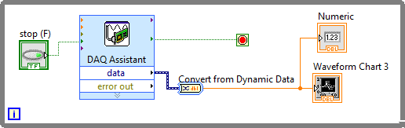
  - It is recommended to convert the output of the DAQ Assistant to a single scalar. This can be done with a Convert from Dynamic Data block.
    - In the dialog box, scroll down and select Single Scalar.
  - These steps will result in the shown block diagram.
- Verify that the VI works correctly.
- Turn ON the 5 V voltage of the DC power supply.
  - This will not turn on the heat element, since point A on the schematics is disconnected. The heat element is active only when point A is connected.
  - Without the 5 V voltage, the temperature sensor cannot operate.
- Let $V_{0}$ be the voltage of the temperature sensor when the sensor is at the ambient temperature. Measure $V_{0}$ with the numerical indicator of your VI. $V_{0}=$_________mV.
- Unless you know the ambient temperature, assume a ${20}^{∘}$C air temperature in all calculations. Write down the air temperature that you will assume in Celsius degrees: $T_{0}=$__________.
- Modify the VI to display temperature instead of voltage.
  - Use the formula $T=T_{0}-500(V-V_{0})$, where $V$ is the voltage reported by the DAQ assistant and $V$ and $V_{0}$ are in volts.
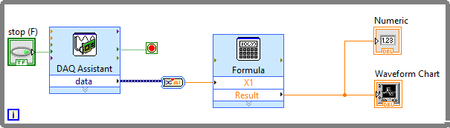
  - You may use the formula block from Express/Arith & Compare to convert voltage to temperature.
- Verify that the VI displays correctly the temperature. While touching the heat sink, verify that the displayed temperature changes.
- Modify the VI to log the measured temperatures to a file.
  - Locate the block Write to a measurement file in the Express/Output.
  - Add the block to the block diagram and configure it as follows.
    - Segment headers: one header only.
    - x-value: 1 column per channel.
    - Select Ask use to choose file, or else specify in Filename the file in which data should be recorded.
- Verify that the VI records correctly temperature to a file. Open the file and make sure it has the right data.
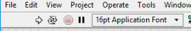
  - To run the program, press the Single Run button.
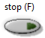
  - To terminate the program without saving the data press the red button.
  - To stop and save the data, press the STOP button.
- To clear the waveform chart, right click on it and select Data Operations.
- The waveform chart will be most useful with the following options:
  - Auto scale on X.
  - Chart History Length of 1024 or more.
- Use the waveform generator to obtain a square wave according to the following specifications.
  - The frequency should be 1.234 kHz.
  - The peak value should be 5V.
  - The minimum value should be 0V.
  - The duty cycle should be 20%.
The following procedure is suggested: (a) Set first the output on High-Z; (b) Set the frequency; (c) Adjust the duty cycle; (d) Adjust the amplitude and offset to ensure the signal varies between 0 and 5V.
- Measure the output of the waveform generator on the oscilloscope.
Peak value: _____ Minimum value: ______ Duty cycle: ______
- Connect the GND of the waveform generator to the GND of NI Elvis or NI SC2705. For example, you could use the BNC1 or BNC2 connectors of NI Elvis and then connect the minus terminal of the connectors to the GND of NI Elvis.
- Up to this point the heat source (MJE800) has been off. Make sure that the heat source is turned on only while the VI is running, in order to be able to monitor the temperature. Do not allow the temperature to exceed ${80}^{∘}$C!
- The heat source can be turned on/off by connecting/disconnecting the function generator to/from the point A on the schematics.
- To acquire data:
  - Turn on the VI and the heat source at the same time.
HEATING
COOLING
  - Wait until the temperature reaches a steady state. (This may take a few minutes.)
  - Without turning off the VI, turn off the heat source.
  - Wait until the temperature reaches a steady state (this may take a few minutes.)
  - Turn off the VI.
  - You should obtain a curve similar to the one in the figure.
  - Make sure you save the acquired data.

- Measure the current flowing out of the E terminal of the heat source.
  - Connect an ammeter to measure the current. Use the high-current terminal of the meter.
  - Turn on the heat source.
  - $I=$_________
  - Turn off the heat source.
  - The power applied by the heat source can be calculated by multiplying the current by 5V.
$P=$_________

- Open the logged data in Microsoft Excel and graph temperature with respect to time.

- The heating part of your curve is described by an equation:
$$t_{0}$$
$$t_{0}^{'}$$
$$x\left(t_{0}^{'}\right)≈x_{h}(∞)$$
$$x_{c}(∞)$$
$$x\left(t\right)=x_{h}\left(∞\right)+\left(x_{h}\left(t_{0}\right)-x_{h}\left(∞\right)\right)e^{- \frac{t-t_{0}}{τ}}$$
- $x_{h}\left(t_{0}\right)$ is the initial temperature when heat is turned on.
- $x_{h}(∞)$ is the steady-state temperature that would be reached if the heat stayed at the same level forever and the environment (the air temperature) did not change.
- Note that $x_{h}\left(∞\right)≈x(t_{0}^{'})$, where $t_{0}^{'}$ is the time when heat is turned off and the system begins to cool down.

- The cooling part of your curve is described by an equation:
$$x\left(t\right)=x_{c}\left(∞\right)+\left(x_{c}\left(t_{0}^{'}\right)-x_{c}\left(∞\right)\right)e^{- \frac{t-t_{0}}{τ}}$$
- $x_{c}\left(t_{0}^{'}\right)$ is the initial temperature when the system begins to cool.
- $x_{c}(∞)$ is the steady-state temperature that would be reached if no heat was applied forever and the environment (the air temperature) did not change.
- Note that $x_{h}\left(∞\right)≈x(t_{0}^{'})$, where $t_{0}^{'}$ is the time when heat is turned off and the system begins to cool down.

- The time constant $τ$ can be calculated using either the heating curve or the cooling curve.
- Two methods will be used to find $τ$:
- The 63% method.
- The slope method.

- The 63% method assumes that the data points satisfy an equation of the form
$x\left(t\right)=x\left(∞\right)+\left(x\left(t_{0}\right)-x\left(∞\right)\right)e^{- \frac{\left(t-t_{0}\right)}{τ}}$.

Note that $x\left(t_{0}+τ\right)=x\left(∞\right)+\left(x\left(t_{0}\right)-x\left(∞\right)\right)⋅e^{-1}$. Therefore, to find $τ$:
- Select $t_{0}$. This can be any point on the exponential curve, such as the starting point.
$t_{0}= ________$.
- Find $x(t_{0})$ and $x(∞)$ from the experimental data. Note that $x(∞)$ denotes the steady-state value of $x(t)$.
$x(t_{0})$ = _______ and $x(∞)$ = ________.
- Calculate $x(t_{0}+τ)$ with the formula $x(t_{0}+τ)=x\left(∞\right)+\frac{x\left(t_{0}\right)-x(∞)}{e}$.
$x\left(t_{0}+τ\right)=______$
- Let $t_{63}$ be the time $t$ at which $x\left(t\right)≃x(t_{0}+τ)$. Find this time.
$$t_{63}=________$$
- Find $τ$ with the equation $τ=t_{63}-t_{0}$.
$$τ=_________$$
- The name of the method comes from the fact that
$x\left(t_{63}\right)-x\left(t_{0}\right)=\left(x\left(∞\right)-x\left(t_{0}\right)\right)⋅\left(1-e^{-1}\right)≃0.632⋅\left(x\left(∞\right)-x\left(t_{0}\right)\right)$.

- The slope method:
- Obtain a scatter plot of $F\left(t\right)=\ln{\frac{x\left(t\right)-x(∞)}{x\left(t_{0}\right)-x(∞)} }$versus time. Ideally, it will be a straight line.
- Use a trend line to find the slope.
- If $F$ is on the x axis and $t$ on the y axis, the slope of the line is $-τ$. (However, if F is on the y axis and $t$ is on the x axis, the slope will be _______.)
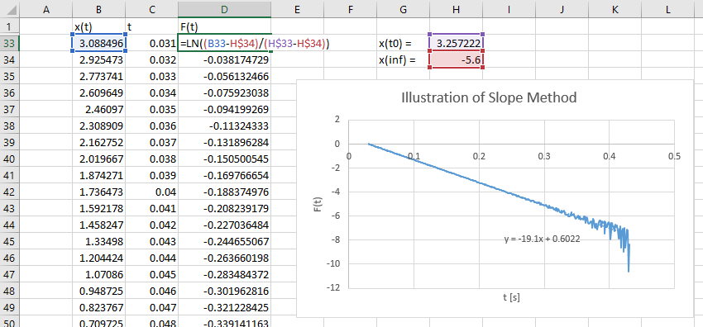
- See the figure for an illustration.
Display trend line equation to find the slope.
For best results do not include the part of the curve that is affected by noise.
Use a scatter plot
- $τ=_________$

- Using the following equivalent circuit, determine the thermal resistance $R$ and the thermal capacitance $C$. Use proper units! $R=____________$ and $C=____________$.
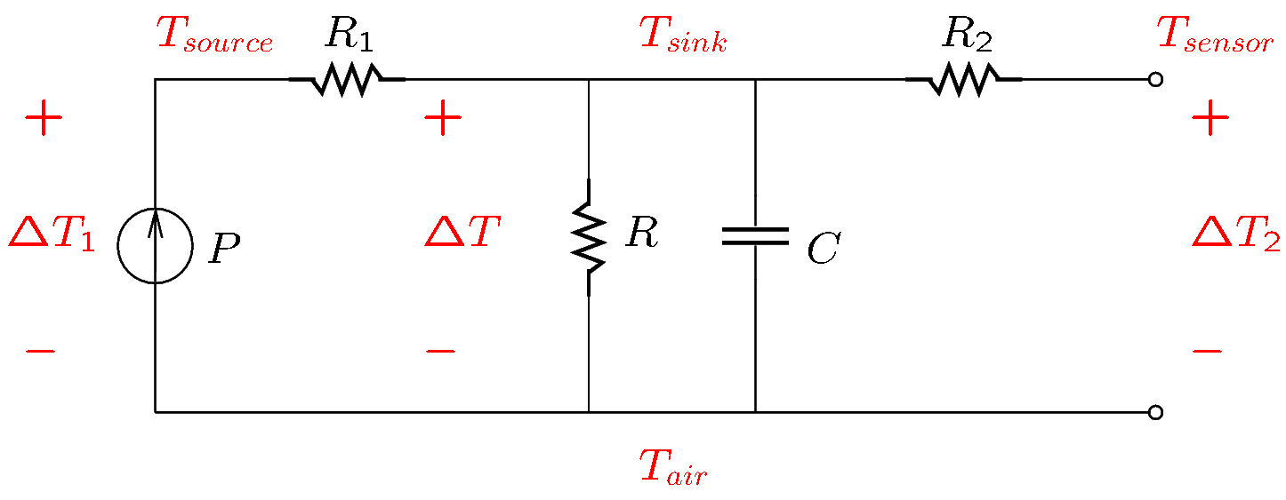

- A formal lab report is required for this lab. See instructions on Canvas. Make sure you save all your data. Do not submit this handout. Submit the formal lab report only.

