Operational Amplifiers—Lab 7

M.V. Iordache, EEGR2051 Circuits and Measurements Lab, Fall 2020, LeTourneau University

See https://mviordache.name/EEGR2051 for more information.

Name: ____________________________ Date Performed: _______________ Section: ___

Operational Amplifiers
Objectives: To introduce operational amplifiers and several common operational amplifier circuits.
Equipment:
- One oscilloscope, one waveform generator, one DMM, one triple DC power supply.
- One operational amplifier (such as 4741); capacitors: $1×10 nF$ and $1×47 μF$; resistors: $2×1 kΩ$, $1×10 kΩ$, and $1×100 kΩ$.
Procedure:
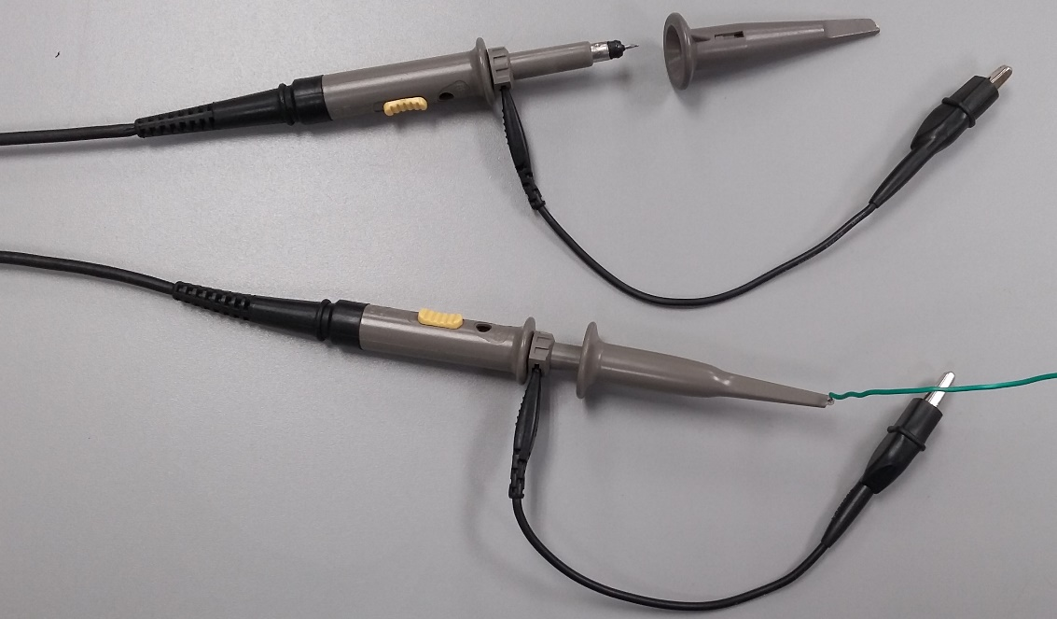
- Oscilloscope probes are devices used when measuring signals with the oscilloscope. The figure shows the main components of a passive probe.
Frequency compensation
adjustment
GND clip
Signal clip
switch
Probe tip
GND shield

- The signal clip of a probe allows attaching the probe securely to a conductor. Note that the signal clip may be removed.
- The switch selects between the 1X mode and the 10X mode.
  - In 1X mode the signal is sent as it is to the oscilloscope.
  - In 10X mode the oscilloscope receives the signal divided by 10.
- Obtain an oscilloscope probe with a switch.
- Test the probe as follows.
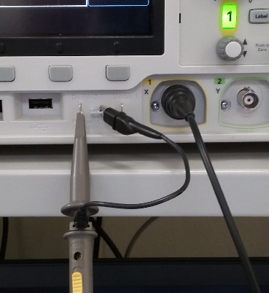
  - Connect the probe to CH1.
  - Connect the signal clip or the tip of the probe to the PROBE COMP terminal of the oscilloscope.
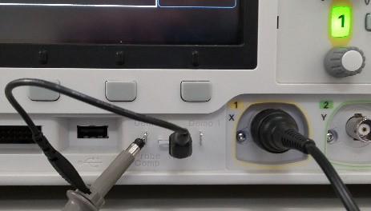
  - Connect the GND clip to the GND terminal.
  - When the probe is in 1X mode, the oscilloscope should display a square wave of about 2 V peak-to-peak.
  - When the probe is in 10X mode, the oscilloscope should display a square wave of about 200 mV peak-to-peak.
  - To test the probe automatically, press the 1 button, select Probe, and then the Probe Check item; then follow the on-screen instructions.
  - For the remaining part of this lab assignment, use the probe in 1X mode.

- Connect the blue rails of your breadboard with a jumper wire. The blue rails will serve as the GND reference.
- Adjust the source 1 of the DC power supply for a voltage limit of $9 V$ and a current limit of $0.03 A$.
- Adjust the source 2 of the DC power supply for the same settings: $9 V$ voltage limit and $0.03 A$ current limit.
- Connect the $–$ of source 1 to the $+$ of source 2, so that the sources are in series.
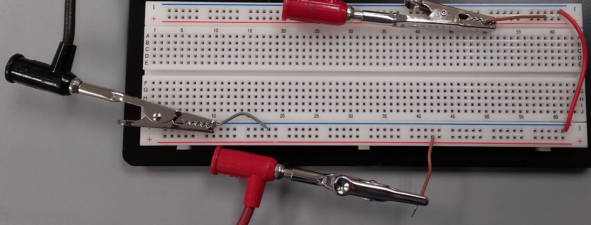
- A possible way of connecting the power supply to the breadboard is by means of banana-to-banana cables, alligator clips, and wire jumpers.

- Connect the $–$ of source 1 to the blue rails of the breadboard. The blue rails will serve as the GND reference of the circuit.
- Connect the $+$ terminal of source 1 to one red rail of the breadboard. This will serve as the positive supply rail.
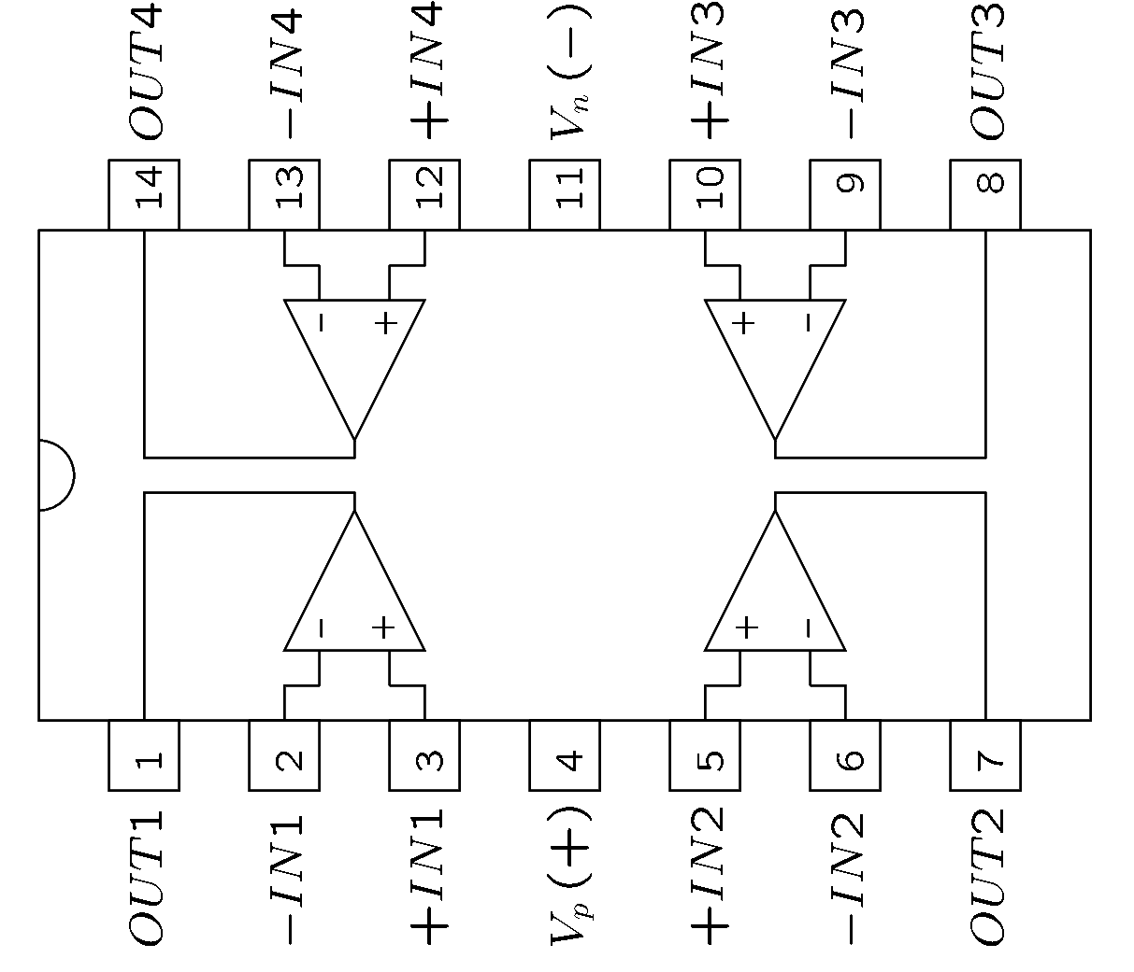
- Connect the $–$ terminal of source 2 to the other red rail of the breadboard. This will serve as the negative supply rail.
- Identify the positive supply pin $V_{p}$ of the operational amplifier (pin 4 of 4741) and the negative supply pin $V_{n}$ (pin 11 of 4741).
- Throughout the lab experiment:
  - The positive supply pin $V_{p}$ of the operational amplifier must be connected to the positive supply rail.
  - The negative supply pin $V_{n}$ of the operational amplifier must be connected to the negative supply rail.
- Connect the operational amplifier to the breadboard.
  - The pin $V_{p}$ (pin 4 of 4741) must be connected to $+9 V$.
  - The pin $V_{n}$ (pin 11 of 4741) must be connected to $-9V$.
- Verify with a DMM that you have $+9-\left(-9\right)=18 V$ between the $V_{p}$ and $V_{n}$ pins. If you measure a different voltage, check your connections.
- Adjust the waveform generator to a sine wave of 200 mV peak-to-peak and 200 Hz.
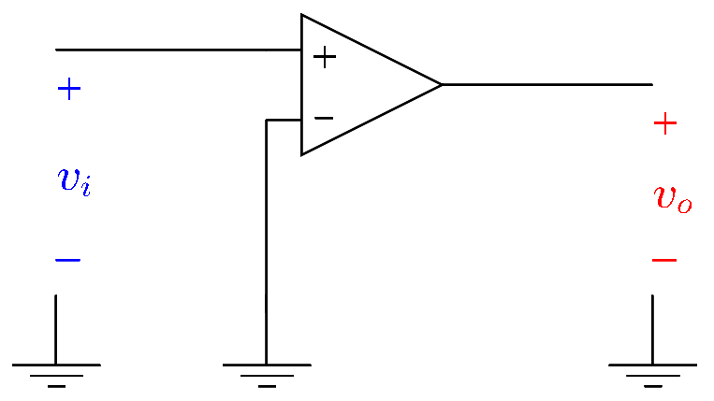
- If using a chip with multiple operational amplifiers (such as 4741), choose one operational amplifier and identify its OUT, $+IN$ , and $-IN$ terminals.
- Using a T-adapter and coaxial cables, connect the waveform generator to
  - CH2 of the oscilloscope.
  - The pin $+IN$ of the operational amplifier.
- Connect the GND of the waveform generator to the GND of the breadboard (the blue rails).
- Connect the $-IN$ pin of the operational amplifier to GND (the blue rails).
- Connect the $OUT$ pin of the operational amplifier to CH1 of the oscilloscope (use the oscilloscope probe or some other coaxial cable).
- Press the Channel button of the waveform generator and turn on the output.
- Visualize the CH1 and CH2 waveforms on the oscilloscope.
  - Are the voltages in phase or out of phase? _________________________
  - Is the output voltage close to $+9 V$ when the input (the waveform generator voltage) is positive? ____________________
  - Is the output voltage close to $-9 V$ when the input is negative? ____________________
- Disconnect the $+IN$ pin from the waveform generator.
- Disconnect the $-IN$ pin from GND.
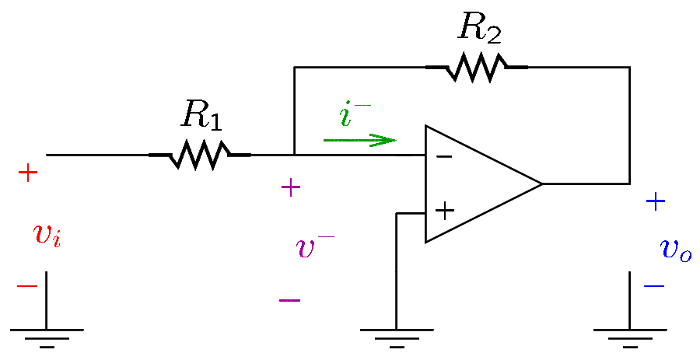
- Set the waveform generator to 50 mV peak-to-peak and 200 Hz.
- Connect the circuit shown in the figure.
  - Use $R_{1}=1 kΩ$.
  - Connect one end of $R_{1}$ to the waveform generator and the other and to $-IN$, as shown in the figure.
  - Make sure that the $OUT$ pin continues to be connected to CH1 of the oscilloscope.
  - Several values of $R_{2}$ will be used (see below).
- Measure the input and output voltages for each of the following values of $R_{2}$: $1 kΩ$, $10 kΩ$, and $100 kΩ$.
  - Record the peak-to-peak values of the voltages in the table below.
  - Record also the phase difference between the input and output voltages.
  - Calculate the amplification of the circuit $A_{v}=v_{0}/v_{i}$ and record in the table.
  - Calculate also $A_{v}$ in decibels.
 | $v_{i}$ (pk-pk) | $v_{o}$ (pk-pk) | Phase difference $[^{∘}]$ | $$A_{v}$$ | $A_{v}$ in dB
$$R_{2}=1 kΩ$$
$$R_{2}=10 kΩ$$
$$R_{2}=100 kΩ$$

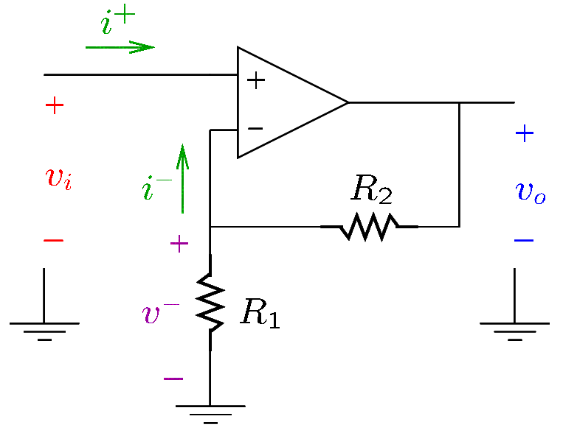
- Connect the circuit shown in the figure.
  - Use $R_{1}=1 kΩ$.
  - Disconnect $R_{1}$ from the waveform generator and connect instead to GND (blue rails).
  - Connect the $+IN$ pin to the waveform generator.
  - Make sure that the $OUT$ pin continues to be connected to CH2 of the oscilloscope.
  - Several values of $R_{2}$ will be used (see below).
- Measure the input and output voltages for each of the following values of $R_{2}$: $1 kΩ$, $10 kΩ$, and $100 kΩ$.
  - Record the peak-to-peak values of the voltages in the table below.
  - Record also the phase difference between the input and output voltages.
  - Calculate the amplification of the circuit $A_{v}=v_{0}/v_{i}$ and record in the table.
  - Calculate also $A_{v}$ in decibels.
 | $v_{i}$ (pk-pk) | $v_{o}$ (pk-pk) | Phase difference $[^{∘}]$ | $$A_{v}$$ | $A_{v}$ in dB
$$R_{2}=1 kΩ$$
$$R_{2}=10 kΩ$$
$$R_{2}=100 kΩ$$

- The minimum and maximum possible values of the output depend on the values of the positive and negative voltage supplies. Using the same circuit and $R_{2}=100 kΩ$, adjust the amplitude of the input until the maximum unclipped output (undistorted sine) is obtained. Measure the peak voltage of the output and draw the waveform below.

Adjust the amplitude of the input until clipping is clearly observed. Measure the positive and negative peak voltages and draw the output waveform below:

Increase the positive and negative supply voltages from $9 V$ to $15 V$. Do not exceed 15 V. How does this affect the output signal? ____________________________________________________________________________
- Measure the average value of the current that enters the positive supply pin $V_{p}$ of the chip (this is terminal 4 of 4741): $I_{p}=$__________.
- Measure the average value of the current that leaves the negative supply pin $V_{n}$ of the chip (this is terminal 11 of 4741): $I_{n}=$__________.
- The following exercise verifies that feedback may cause instability. Connect the circuit below and notice that it is unstable: it oscillates even though no input is applied to the circuit! Draw the graph of $v_{o}$. The peak to peak value of the output signal is ________. The frequency is ______.
