Sources, Multimeters, and Transformers—Lab 5

M.V. Iordache, EEGR2051 Circuits and Measurements Lab, Fall 2020, LeTourneau University

See https://mviordache.name/EEGR2051 for more information.

Name_____________________________________ Date Performed_____________ Section____

Sources, Multimeters, and Transformers

Objectives: Learn to use DC power supplies and multimeters. Observe the loading effect.

Equipment: Two digital multimeters (DMMs).
One double or triple DC power supply with adjustable current limit.
One waveform generator.
One transformer #051727401 or #29590.
One $25 Ω$ rheostat and miscellaneous resistors.

Procedure:

- Select two identically coded resistors from within each of the following ranges:

LOW: 50 $Ω$ to 100 $Ω$ MEDIUM: 110 $Ω$ to 330 $Ω$ HIGH: 1 M$Ω$ to 22 M$Ω$

- Identify the resistors as:

  - $R_{LO1}$ and $R_{LO2}$ b. $R_{ME1}$ and $R_{ME2}$ c. $R_{HI1}$ and $R_{HI2}$

- Measure the resistors with the DMM and write their value in Table 1.

Table 1 – MEASURED RESISTANCE VALUES
Measured Values [ Ω ] |  | Nominal (Expected) Value [ Ω ]
$$R_{LO1}=$$ | $$R_{LO2}=$$
$$R_{ME1}=$$ | $$R_{ME2}=$$
$$R_{HI1}=$$ | $$R_{HI2}=$$

- Current measurement: In the following steps current will be measured with a DMM. Select one of the DMMs for current measurements.
- Locate the terminal for low current ranges and read the maximum admissible current value recorded on the front panel: __________.
- Locate the terminal for high current ranges and read the maximum admissible current value recorded on the front panel: __________.
- The low current terminal is fuse protected. When current exceeds the maximum admissible value, the fuse will be blown. When the fuse is blown, no current can flow through the terminal of the DMM.
- Assuming the DMM measures current and the fuse is blown, indicate which of the following will happen: (a) The DMM will indicate zero or a very small current; (b) The DMM will display the correct value of the current; (c) The DMM will indicate overload; (d) None of the previous.
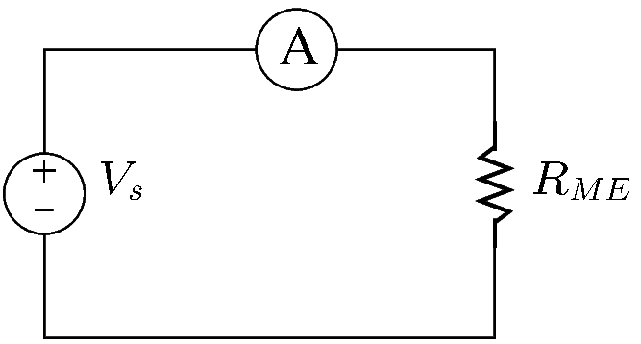
- Turn on the DC power supply.
- Set the voltage limit to $V_{s}=0.2 V$.
- Set the current limit to $0.1 A$.
- Connect the DMM as shown in the figure, using one of the medium valued resistors
  - The DMM terminal for low current ranges should be connected to the positive terminal of the source.
  - The COM terminal of the DMM should be connected to the resistor.
- Press the AUTO button of the DMM to ensure that the instrument will select automatically the right current range.
- By Ohm’s law, the expected value of the current of the circuit is __________.
- Due to the loading effect, the measured value of the current should be somewhat lower than its expected value.
- Measure the current of the circuit. _______________
- If the measured current is greater than its expected value, check your connections and redo the current measurement.
- If the measured current is less than $400 μA$, check your connections and redo the current measurement.
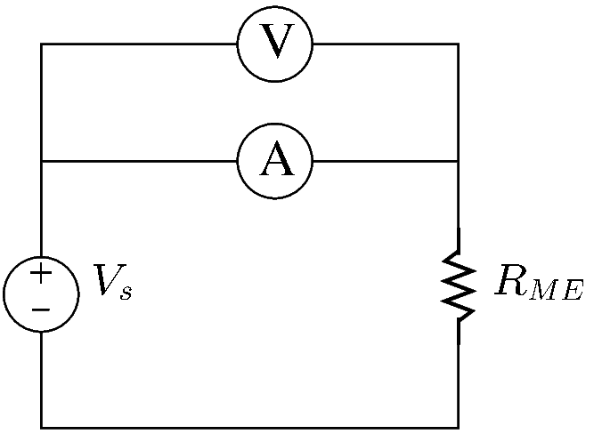
- To evaluate ammeter loading, measure the voltage of the ammeter with a second DMM. Connect the second DMM as shown in the figure.
- The ammeter voltage is ___________.
- Divide the ammeter voltage by the measured current. The ammeter resistance is ___________.
- Without disconnecting the second DMM, increase the voltage of the source until the ammeter displays a value of approximately $50 mA$.
- The measured current is _______________
- The ammeter voltage is _______________
- Divide the ammeter voltage by the measured current. The ammeter resistance is ___________.
- The ideal resistance of an ammeter is zero. Comparing the answers at steps ‎21 and ‎25. In which case is the loading effect more noticeable, when measuring larger or lower currents? ________________________________________________________________________
- Press the AUTO button to ensure that the DMM measuring current is in auto mode.
- When in auto mode, the DMM does not measure the current of the terminal for high current ranges.
- Verify that the reading of the DMM is incorrect when using the terminal for high current ranges in auto mode. The reading is __________.
- The DMM reads the terminal for high current ranges when its range is set manually to a value above $1 A$.
- Change manually the range of the DMM that measures current to the least range greater or equal than $1 A$. Verify that the DMM reading is now correct. The reading is ______________.
- If the reading a step ‎31 is considerably different from the reading of step ‎23, check your work.
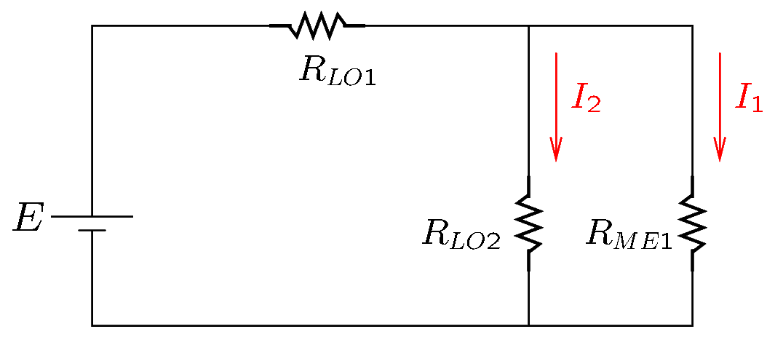
- Connect the circuit shown in the figure.
- Adjust the current limit to $0.45 A$.
- Adjust the voltage limit to $E=5 V$.
- Measure $I_{1}$ and $I_{2}$ with the DMM:
$I_{1}$ = ____________
$I_{2}$ = ____________.
- Measure the voltage on $R_{ME1}$ and $R_{LO2}$.
DMM reading: ____________
- Apply Ohm’s law to calculate the currents $I_{1}$ and $I_{2}$ using the measured voltage and the values of $R_{LO2}$ and $R_{ME2}$.
$I_{1}$ = ____________; $I_{2}$ =____________.
- Redo all current measurements that are not sufficiently close to the calculated values.
- Theoretically, what should be the total resistance seen by the source of voltage? ___________
- Disconnect the source of voltage from the circuit.
- Measure the total resistance with the DMM. $R_{tot}=$__________________
- Reconnect the source of voltage and measure the current of the source. $I=$__________
- Indicate whether $I=I_{1}+I_{2}$
- Calculate $I_{1}$ and $I_{2}$ using current division.
$I_{1}$ = ____________; $I_{2}$ =____________.
- Connect the following circuit. Use $E=10$V, R₁ = $R_{ME1}$ and R₂ = $R_{ME2}$.
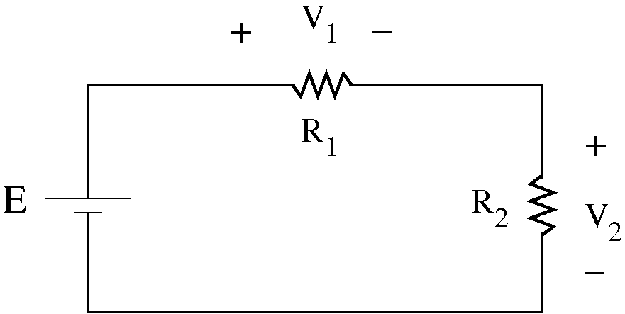
- Theoretically, assuming R₁ = R₂, what should be the value of the voltages V₁ and V₂?
V₁ = _________ and V₂ = _________
- Measure V₁ and V₂.
V₁ = _________ and V₂ = _________

- The Loading Effect: Ideally, voltmeters should not load a circuit, that is, no current should flow through a voltmeter. In reality, voltmeters can change circuit voltages when connected to a circuit. This phenomenon is known as the loading effect. The loading effect is noticeable when the voltmeter is in a network involving large resistor values.
- Reconnect the circuit using R₁ = $R_{HI1}$ and R₂ = $R_{HI2}$.
- What is the expected value of V₂? V₂ = __________.
- Measure V₂ by connecting one DMM across R2: V₂ = __________.
- Connect two DMMs across R2 and measure again the voltage: V₂ = __________.
- Is the loading effect demonstrated? How? ___________________________________________
_____________________________________________________________________________
_____________________________________________________________________________
- Reconnect the circuit using R₁ = $R_{LO1}$ and R₂ = $R_{LO2}$.
- Measure V₂ by connecting one DMM across R2: V₂ = __________.
- Connect two DMMs across R2 and measure again the voltage: V₂ = __________.
- Is the loading effect noticeable? Explain. ___________________________________________
_____________________________________________________________________________
_____________________________________________________________________________
- Disconnect the circuit and the DMMs.
- The loading effect is noticeable when the DMM is connected to a network involving resistors that have a comparable or larger value than the resistance of the DMM.
- Measure the resistance of the DMM when used as a voltmeter. Use another DMM to read its resistance. $R_{v}=$____________
- Measure the resistance of the DMM when used as an ammeter. Use another DMM to read its resistance. $R_{v}=$____________
- Verify that a DMM that measures resistance applies a voltage to the component it measures. Measure that voltage with another DMM. $V_{Ω}=$____________

The Transformer
- Obtain either the Large Transformer (#29590) or the Small Transformer (#051727401).
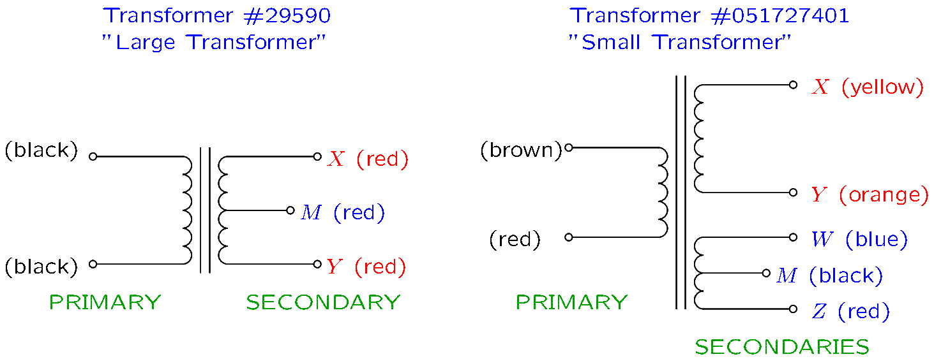
- Indicate the transformer that you selected ____________________.

- Identify the primary and the secondary terminals of your transformer.
  - Note that the primary terminals are on one side of the transformer and the secondary terminals on the other side.
  - Locate the X and Y secondary terminals.
  - The X and Y secondary terminals will be used throughout this exercise.
- Connect the waveform generator to the primary of the transformer.
  - Adjust the waveform generator for a zero-mean sinewave of 100 Hz and a voltage within the range 5…20 V_{pp}.
  - Note that the generator will not output any voltage until you select Channel/Output/ON.
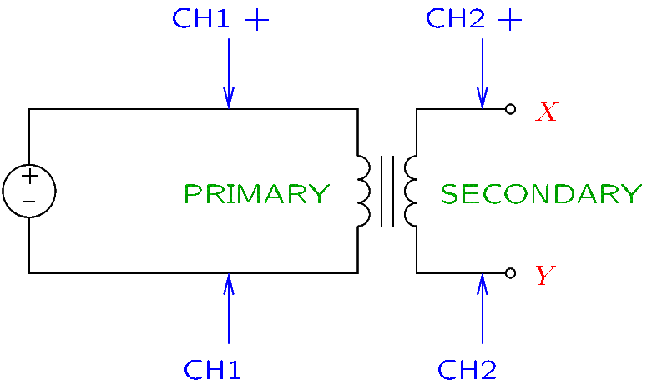
- Connect the oscilloscope to the circuit as shown in the figure.
  - Ensure that both channels 1 and 2 of the oscilloscope are ON.
  - Connect channel 1 to the primary.
  - Connect channel 2 to the X and Y secondary terminals.
  - Press the Trigger button of the oscilloscope and select channel 1 as the trigger source.

- Measure the peak-to-peak voltage of the primary on the oscilloscope. $V_{p}=$_____________________
- Measure the peak-to-peak voltage of the secondary on the oscilloscope. $V_{S}=$________________
- Using the relationship $\frac{V_{P}}{V_{S}}=\frac{N_{P}}{N_{S}}$, calculate the turns ratio $N_{P}/N_{S}$. ______________
- Adjust the waveform generator for maximum voltage (use the rotary control).
- Connect a cable between the secondary terminals X and Y and measure the rms currents with a DMM.
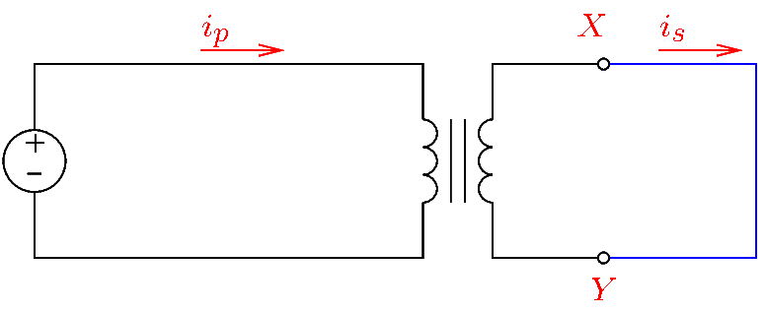
  - Recall that the rms value of AC currents is measured with the DMM in AC mode.
  - Do not use a clamp-on ammeter at this point.

$I_{P}=$_____________ $I_{S}=$_____________

- Verify your results with a clamp-on ammeter.
$I_{P}=$_____________ $I_{S}=$_____________
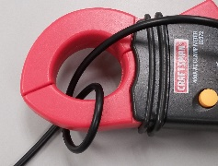
- Consider the measurement of the input current. Wrap the conductor measured with the clamp-on meter around one of the jaws, so that it passes two times between the jaws. The reading is _________________.

- Wrap the conductor measured with the clamp-on meter so that it passes three times between the jaws. The reading is _________________.

- Is the reading of the clamp-on ammeter proportional to the number of turns of the conductor? _____________________________________________________________________________

- Verify that the ratio of the secondary current and the input current is approximately equal to N_{p}/N_{s}.

Current ratio = ________ N_{p}/N_{s} = ________
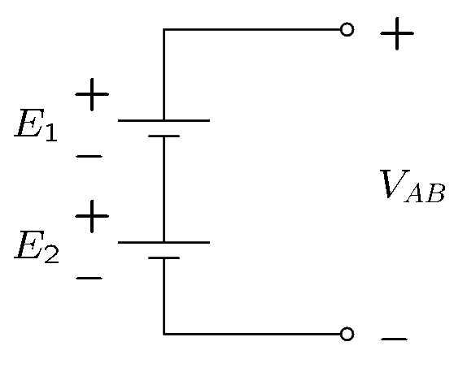
Power Supplies (Optional):

- Voltage sources:
  - The power source will be a voltage source for loads of total resistance $R_{tot}≥\frac{V_{oc}}{I_{sc}}$.
  - The power source will be a current source for loads of total resistance $R_{tot}≤\frac{V_{oc}}{I_{sc}}$.
In other words, the source will maintain a constant voltage as long as the load does not attempt to draw more current than the current limit. If the load attempts to exceed the current limit, the source will limit the current to the prescribed limit and will operate as a current source.
- Connect the following series network using Output 1 and Output 2 of the DC power supply.
- Select arbitrary values for the two sources of voltage.
- Measure the two sources. $E_{1}=$_________ and $E_{2}=$ ___________.
- The expected value of $V_{AB}$ is __________.
The measured value is _________.
- Sources of voltage are not connected in parallel. The only exception is when it is possible to guarantee that they will operate at safe current levels when connected in parallel. Thus, identical batteries may be connected in parallel. Sources that limit the output current may also be connected in parallel.
- Set to 1.2 A the current limit of Output 1.
- Set to 1.2 A the current limit of Output 2.
- Adjust the supply so that it outputs $E_{1}=E_{2}=2$ V.
- Adjust the rheostat so that there is $1 Ω$ between two of its terminals (use a DMM to measure it).
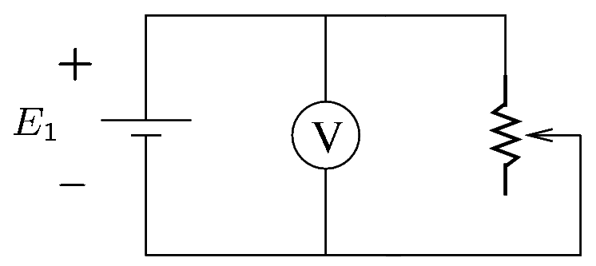
- Connect these two terminals of the rheostat to a voltmeter and to the source of value $E_{1}$.
- Verify that the source is unable to maintain $2$V on the $1 Ω$ load.
$E_{1}$ drops to _______.
- By Ohm’s law, the current of the rheostat should be __________.
Does this value agree with the current displayed by the source? Yes __ No __.
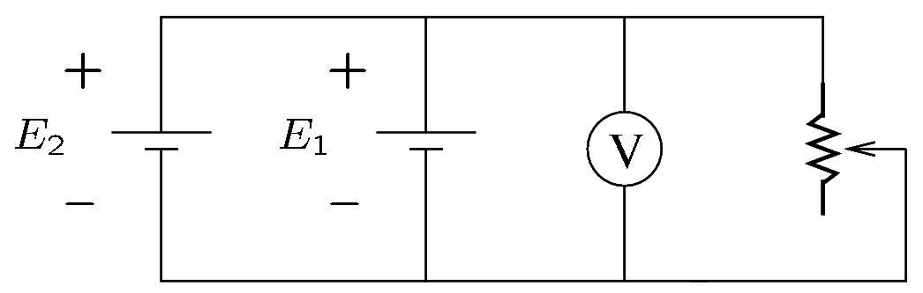
- Connect the source of value $E_{2}$ in parallel, making sure that the + terminal of $E_{2}$ is connected to the + terminal of $E_{1}$, and the $–$ terminal of $E_{2}$ is connected to the $–$ terminal of $E_{1}$.
- The voltage across the load is ________.
- Explain why the sources are capable to maintain their set voltage when connected in parallel. ________________________________________________
_____________________________________________________________________________
_____________________________________________________________________________
_____________________________________________
- Explain why it is safe to connect the two sources in parallel. _____________________________________________________________________________
_____________________________________________________________________________
_____________________________________________________________________________

