DC Sources and Multimeters—Lab 2

M.V. Iordache, EEGR2051 Circuits and Measurements Lab, Fall 2020, LeTourneau University

See https://mviordache.name/EEGR2051 for more information.

Name_____________________________________ Date Performed_____________ Section____

DC Sources and Multimeters

Objectives: Learn to use DC power supplies and multimeters. Observe the loading effect.

Equipment: Two digital multimeters (DMMs).
One double or triple DC power supply with adjustable current limit.
Miscellaneous resistors.
Procedure:

- Select two identically coded resistors from within each of the following ranges:

LOW: 27 $Ω$ to 100 $Ω$ MEDIUM: 200 $Ω$ to 2 k$Ω$ HIGH: 1 M$Ω$ to 22 M$Ω$

- Identify the resistors as:

  - $R_{LO1}$ and $R_{LO2}$ b. $R_{ME1}$ and $R_{ME2}$ c. $R_{HI1}$ and $R_{HI2}$

Resistance Measurements
- The electric resistance of a conductor is associated with the resistance encountered by charge carriers when flowing through the conductor. When charge carriers can flow freely, the resistance is zero; when charge carriers cannot flow at all, the resistance is infinite.
  - The resistance of a wire is very small (ideally zero.)
  - The resistance between two points that are not connected is very large (ideally $∞$.)
- A DMM will report overload when the measured value exceeds the selected range or the capabilities of the instrument. For example, when measuring 20 V on the 2 V range, the DMM will report overload.
- When a DMM reports overload, it displays OVLD, or OL, or I.
- Select a DMM and identify the red terminal marked with $Ω$; resistance is measured between the $Ω$ terminal and the black COM (common) terminal.
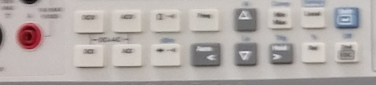
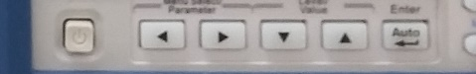
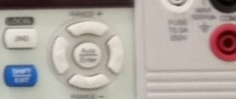
- Turn on the DMM, press the $Ω$ button to select resistance measurement, and select the auto mode by pressing the auto button (in this way the measurement range will be selected automatically).
- What does the DMM display when nothing is connected to it? ____________
Explain why: __________________________________________________________________
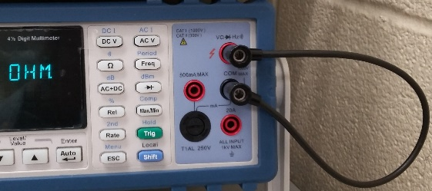
- What does the DMM display when you connect a wire between the Ω terminal and the common terminal? ________. Why? ____________________________________________
_________________________________________________
- Measure the resistors with the DMM and write their value in Table 1.
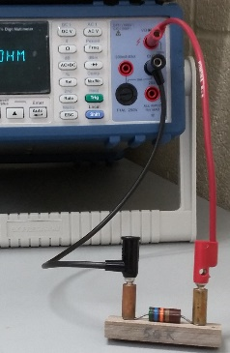

Table 1 – MEASURED RESISTANCE VALUES
Measured Values [ Ω ] |  | Nominal (Expected) Value [ Ω ]
$$R_{LO1}=$$ | $$R_{LO2}=$$
$$R_{ME1}=$$ | $$R_{ME2}=$$
$$R_{HI1}=$$ | $$R_{HI2}=$$

DC Power Supplies
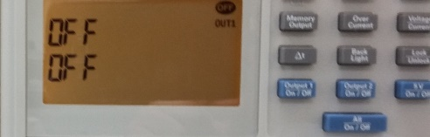
- Turn ON the DC power supply.
- Make sure the power supply outputs are turned OFF. (The screen should display OFF. If not, press the blue buttons to turn all outputs OFF.)
- While the outputs of the source are turned OFF:
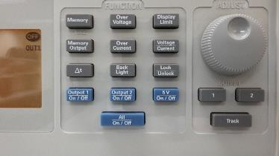
  - Set the current limit of Output 1 to 1A.
- Press 1 to adjust Output 1.
- Press Display Limit, and then Voltage/Current once or twice until A blinks.
- Turn the knob until the display shows 1A.
  - Set the voltage of Output 1 to the minimum value of 0.01 V.
- Press Display Limit, then Voltage/Current one or twice, until V blinks.
- Turn the knob to obtain 0.01V.
- Continue to keep all outputs OFF.

Current and Voltage Measurements
- Select a DMM for current measurements.
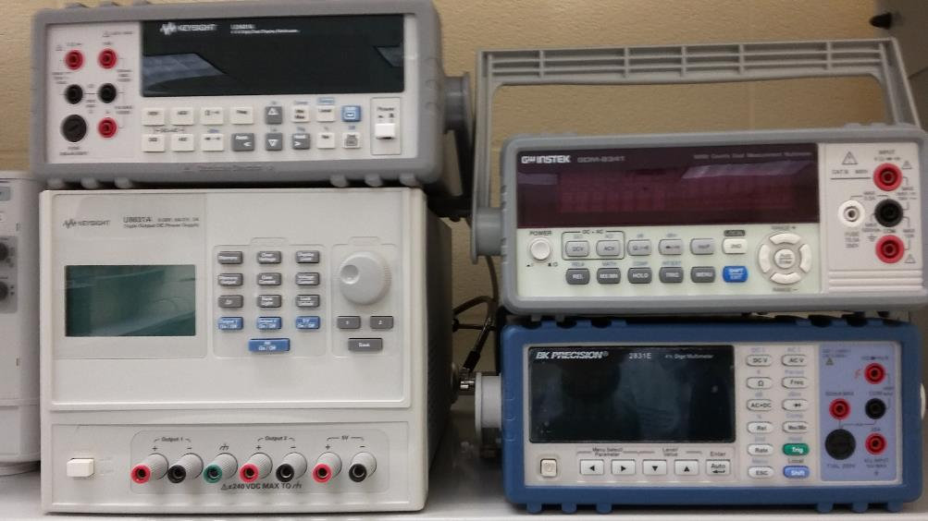
- Identify the terminal for low current ranges and the terminal for high current ranges.
- Read on the front panel the maximum admissible current of the terminal for low current ranges: __________.
- What is the maximum admissible current of the terminal for high current ranges? _________.
- The low current terminal is fuse protected. When the current exceeds the maximum admissible value, the fuse will be blown. When the fuse is blown, no current can flow through the terminal of the DMM.
- Assuming the DMM measures current and the fuse is blown, indicate which of the following will happen: (a) The DMM will indicate zero or a very small current; (b) The DMM will display the correct value of the current; (c) The DMM will report overload; (d) None of the previous.
- Select DCI for DC current measurements.
  - Some DMMs have a DCI button.
  - Other DMMs select DCI by pressing SHIFT+DCV.
- Verify that you can change the range manually. Press the vertical arrow keys to change the range of the current.
- When measuring an unknown current, assume that it is a large current. So, begin by measuring a current using the terminal for high current ranges. This will protect the fuse in case the current is large. However, if the current turns out to be small, it can be measured more precisely using the terminal for low current ranges.
- In the following, we will measure a current using the terminal for high current ranges.
- Since the terminal for high current ranges can only be used in manual mode, the range will be selected manually.
- Change the current range to the least value above 1 A (such as 5 A , or 2 A, etc.).
- Select one more DMM for voltage measurements.
- Continue to keep all outputs of the DC supply OFF while connecting the following circuit.
  - The source should be the Output 1 of the DC power supply.
  - Use R₁ = $R_{LO1}$, and R₂ = $R_{LO2}$.
  - Connect the ammeter using the terminal for high current ranges and the COM terminal.
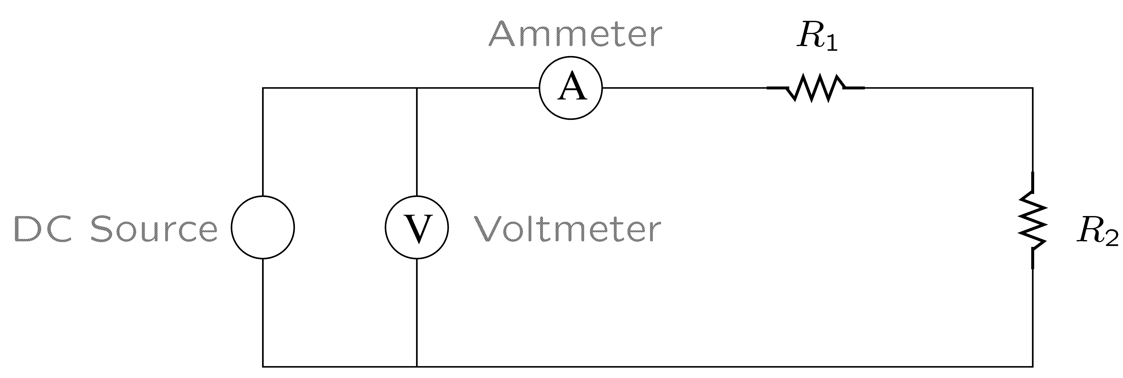
  - Connect the voltmeter using the terminal marked with V (volts) and the COM terminal.
- Turn ON Output 1 of the DC source.
- If the ammeter displays more than 100 mA, turn OFF Output 1 and check your connections.
- Adjust the voltage of Output 1 until the voltmeter indicates 8 V.
- Record the value of the current shown by the DMM: _________.
- Ideally, ammeters should not load a circuit, that is, the voltage across an ammeter should be zero. Measure the voltage across the ammeter using another DMM: ________.
- If the measured current is smaller than the maximum admissible current of the terminal for low current ranges, then:
  - Activate the auto mode.
  - Measure the current with the terminal for low current ranges: ________.
  - Measure again the voltage across the ammeter: _________. In which case does the ammeter load less the circuit, when used with the terminal for high current ranges or the terminal for low current ranges? _____________________

Current Sources
- Many electronic DC power supplies can be operated either as voltage or current sources. This is not true of other DC sources (such as batteries).
- When a wire connects together two terminals of a device, it is known as a short-circuit; we say that the wire shorts or short-circuits the device.
- Turn OFF the outputs of the power supply.
- Adjust the current limit of Output 1 to 50 mA.
- The expected short-circuit current of Output 1 is $I_{sc}=$_______
- Adjust the voltage limit of Output 1 to 18 V.
- Turn ON Output 1.
- The open-circuit voltage of a source is the voltage when no current is drawn from the source.
- Disconnect one of the terminals of the ammeter in order to measure the open circuit voltage of the source. The voltage displayed by the voltmeter is $V_{oc}=$_______
- Reconnect the terminal of the ammeter. Use the terminal for low current ranges.
- The source will operate as a current source for loads involving a total resistance $R_{tot}$ that does not exceed the ratio of the open-circuit voltage and the short-circuit current: $\frac{V_{oc}}{I_{sc}}=$________
- Verify that the current is the same in each of the following cases.
  - Note that a conductor across a resistor or resistor network indicates a short-circuit.
  - Calculate $R_{tot}$ by adding together the values of the resistors that are not shorted; note that a shorted resistor has zero ohms.
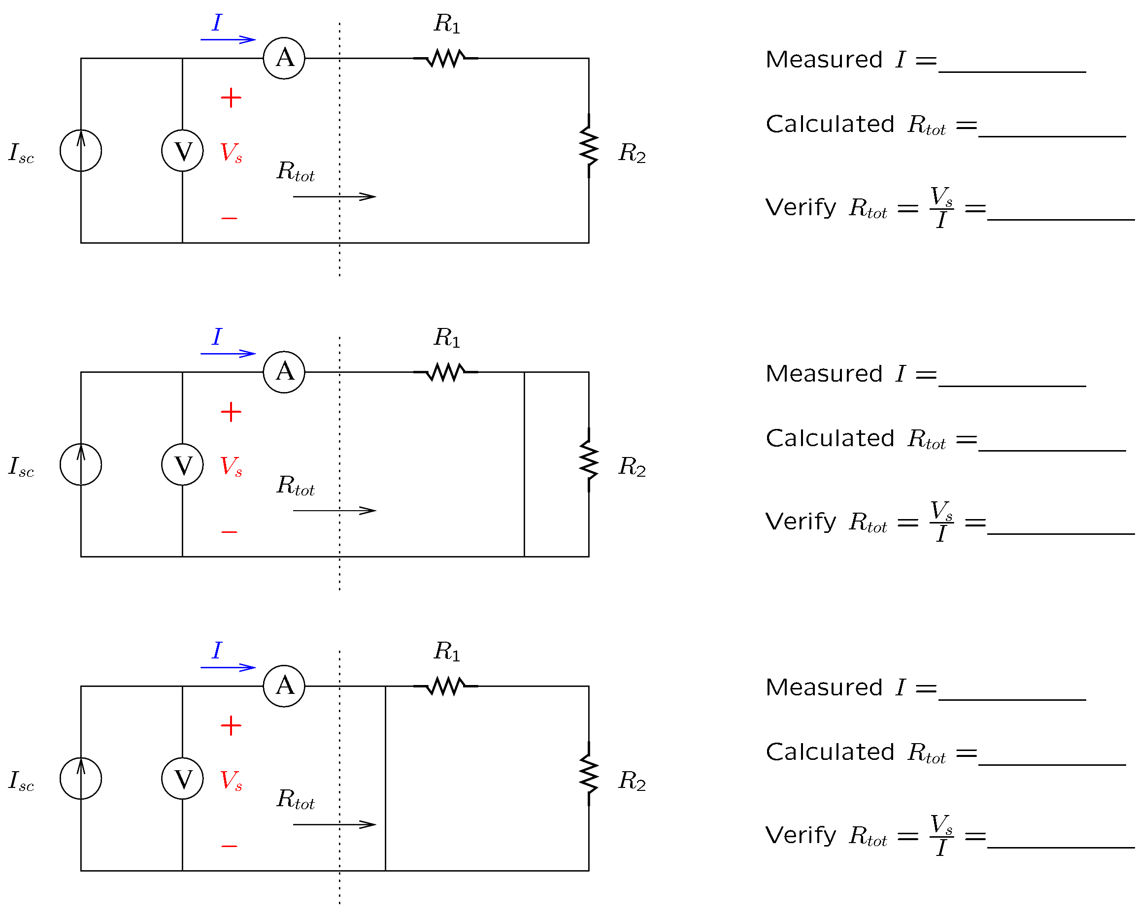
- Using the first circuit of the previous question, measure the current I after changing R₁ to $R_{HI1}$.
$I=$________. Why did the current change? _______________________________________

Voltage Sources
- Note that the power supply operates at the voltage limit as a source of voltage when the total resistance $R_{tot}≥\frac{V_{oc}}{I_{sc}}$.
- However, it operates at the current limit as a source of current when the total resistance $R_{tot}≤\frac{V_{oc}}{I_{sc}}$.
- In other words, the source will maintain a constant voltage as long as the load does not attempt to draw more current than the current limit. If the load attempts to exceed the current limit, the source will limit the current to the prescribed limit and will operate as a current source.
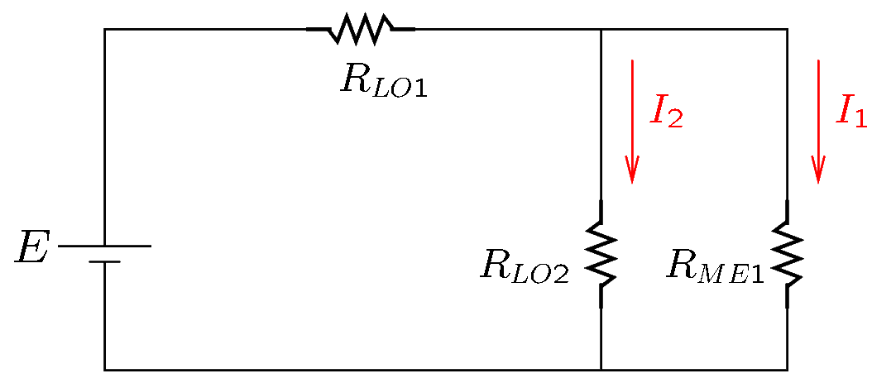
- Connect the circuit shown in the figure.
- Adjust the current limit to 200 mA.
- Adjust the voltage limit to $E=2$V.
- Measure $I_{1}$ and $I_{2}$ with the DMM:
$I_{1}$ = ____________.
$I_{2}$ = ____________.
- Measure the voltage on $R_{ME1}$ and $R_{LO2}$.
DMM reading: ____________
- Apply Ohm’s law to calculate the currents $I_{1}$ and $I_{2}$ using the measured voltage and the values of $R_{LO2}$ and $R_{ME2}$.
$I_{1}$ = ____________; $I_{2}$ =____________.
- Redo all current measurements that are not sufficiently close to the calculated values.

