Power Measurements—Lab 13

M.V. Iordache, EEGR2051 Circuits and Measurements Lab, Fall 2020, LeTourneau University

See https://mviordache.name/EEGR2051 for more information.

Name_________________________ Date__________ Section_____

EEGR 2051 – Power Measurements
Materials
- One $10 Ω$ resistor, one $220 Ω$ resistor, and one $180 Ω$ resistor.
- One $30$mH inductor.
- One capacitor substituter and one resistor substituter.

Procedure
- Measure the three resistors and indicate their actual value.

Nominal Value | $$r=10 Ω$$ | $$R_{1}=180 Ω$$ | $$R_{2}=220 Ω$$
Actual Value

- Set the waveform generator to a sine wave of 600 Hz and 4 V peak-to-peak.
- Verify the voltage of the generator with the oscilloscope.
- From now on, let’s denote by $r$, $R_{1}$, and $R_{2}$ the three resistors, as in the table above.
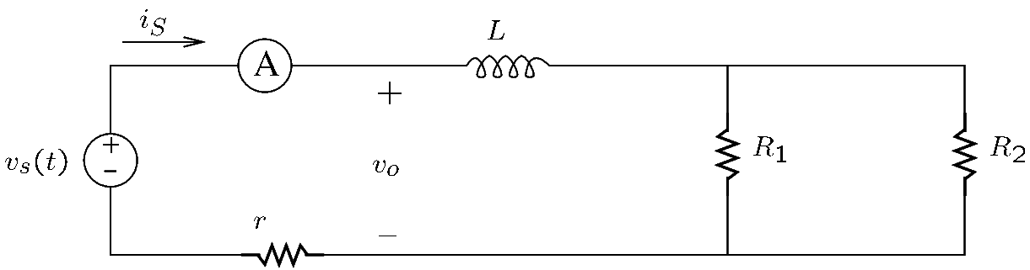
- Connect the following circuit.

- Select manually the range of the ammeter to a value between $20$mA and $500$mA.
- Note that the $r=10 Ω$ resistor will be used to sense the current.
- Connect CH1 of the oscilloscope to the waveform generator and CH2 to the sensing resistor.
- Does the voltage of the source change when you connect the source to the circuit? Explain why.
_______________________________________________________________________________________
- Measure the phase angle difference between the source voltage and the source current. Write the answer in degrees. $Δϕ=$________.
- Indicate whether the current leads or lags the voltage. _______
- The power factor is ____________________.
- Measure the rms value of the load voltage $v_{o}$ shown in the figure above. $V_{o}=$ _____________
- Calculate the apparent power of the load by multiplying $V_{0}$ by the rms current. $S=$__________
- Measure the rms voltage of the inductor. $V_{L}=$_______________
- The reactive power is $Q=$______________
- Measure the rms voltage on either of $R_{1}$ or $R_{2}$. $V_{R}=$___________.
- The average power absorbed by $R_{1}$ is $P_{1}=$____________.
- The average power absorbed by $R_{2}$ is $P_{2}=$____________.
- The total average power is $P=$__________.
- Find $\sqrt{P^{2}+Q^{2}}$. ____________
- Is the equality $S= \sqrt{P^{2}+Q^{2}}$ verified? ________________________
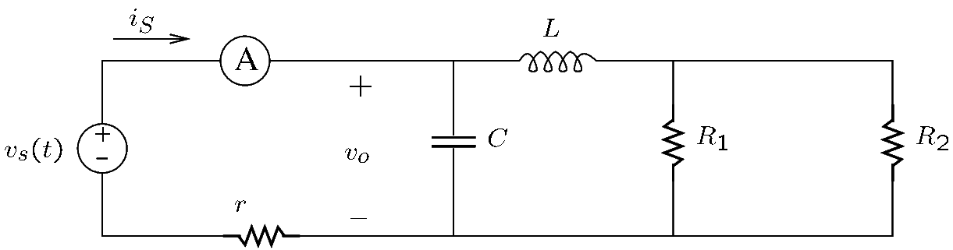
- To correct the power factor, set the capacitor substituter to $100$nF and connect it as in the figure.

- Increase the value of the capacitor substituter and verify that the phase angle difference changes.
- When the power factor is corrected, the load current $i_{S}$ is minimum, and the phase angle difference is zero.
- Adjust the value of the capacitor substituter until the rms value of the current reaches the minimum value. The value at which the power factor is corrected should be in the range $100…3000$nF. $C=$__________
- The phase angle difference is $Δϕ=$________.
- The following part of the experiment will demonstrate that power factor correction is load dependent, that is, changes in the load require readjusting the value of the capacitor.
- Disconnect the resistor $R_{2}$ from the circuit.
- The phase angle difference is now $Δϕ=$________.
- Measure the rms values of the load voltage $v_{o}$ and the load current $i_{s}$. $V_{o}=$__________ $I_{S}=$________
- The apparent power of the load is $S=$___________.
- Measure the rms voltage on $R_{1}$. $V_{1}=$________
- The average power absorbed by $R_{1}$ is $P_{1}=$__________.
- Should the apparent power $S$ equal $P_{1}$? _______________________________________________________
- Readjust the capacitor substituter until the power factor is corrected. $C=$__________
- Measure again the rms voltage on $R_{1}$. $V_{1}=$________
- The average power absorbed by $R_{1}$ is $P_{1}=$__________.
- By Ohm’s law, the rms value of the resistor current is $I_{1}=$__________.
- Measure the rms value of the inductor voltage. $V_{L}=$____________.
- The reactive power of the inductor is $Q_{L}=$______________.
- Measure the rms value of the capacitor current. $I_{C}=$__________
- Measure the rms value of the voltage $v_{o}$. $V_{o}=$____________
- The reactive power of the capacitor is $Q_{C}=$______________.
- The total reactive power of the load is $Q=$____________. Is this correct? ___________________________
_______________________________________________________________________________________
- Measure the rms value of the load current $i_{s}$. $I_{S}=$__________
- The apparent power of the load is $S=$___________.
- Should $S$ equal $P_{1}$? _______________________________________________________________________
- Many pieces of modern equipment tend to absorb power from the supply in an irregular fashion, as they seek to reduce power consumption. However, this can distort the supply voltage to the point that it no longer resembles a pure sinewave. The following questions evaluate the effect of the distortion on the efficiency of a power system.
- Note that a zero-average signal $v\left(t\right)$ of frequency $ω$ can be decomposed into the sum
$$v\left(t\right)=A_{1}\cos\left(ωt+α_{1}\right)+A_{2}\cos\left(2ωt+α_{2}\right)+A_{3}\cos\left(3ωt+α_{3}\right)+…$$
where $A_{1}\cos\left(ωt+α_{1}\right)$ is the fundamental and $A_{n}\cos\left(nωt+α_{n}\right)$ is the harmonic of order $n$.
- The harmonic distortion of a signal can be calculated with the formula
$$Harmonic distortion=\frac{\sqrt{V_{rms}^{2}-A_{1,rms}^{2}}}{A_{1,rms}}$$
where $V_{rms}$ is the rms value of $v(t)$ and $A_{1,rms}=\frac{A_{1}}{\sqrt{2}}$ is the rms value of the fundamental.
- For a pure sinusoidal signal of frequency $ω$, the amplitude of the harmonics is $A_{2}=A_{3}=A_{4}=…=$_____
Moreover, the harmonic distortion is ______.
- Set the waveform generator to a triangle wave. Adjust the amplitude of the waveform generator until the rms voltage on $R_{1}$ equals the value found at part ‎37. This step is important in order to ensure that the triangle wave dissipates as much power on the load as the sinusoidal signal.
- Measure the rms value of the load current $i_{s}$. $I_{S}=$______________.
- Using the oscilloscope, find the rms value of the first harmonic of the source voltage $v_{S}$.
  - Set the time base on $50$ms/div.
  - Press the MATH button, the Operator soft key, and select FFT.
  - Set Source 1 to the channel on which you have the source voltage.
  - If lit, press twice the 1 and 2 buttons to turn off the channels 1 and 2.
  - Press the MATH button and set Span to $5$kHz and Center to $2.5$kHz.
  - Press More FFT and then Window; select Rectangle. Do not press Auto Setup; if you do, you may have to go back to step (a).
  - The largest peak on the screen is the fundamental.
  - Using cursors, measure the value of the fundamental: $A_{1,dB}=$ ____ dB.
  - Convert dB to rms volts. Note that $A_{1,dB}=20\log_{10}{A_{1,rms}}$.
  - $A_{1,rms}=$__________.
- Measure the rms value of the source voltage $v_{S}$. $V_{s, rms}=$____________
- Calculate the harmonic distortion: ______________
- Set the waveform generator to a square wave. Adjust the amplitude of the waveform generator until the rms voltage on $R_{1}$ equals the value found at part ‎37.
- Measure the rms value of the load current $i_{s}$. $I_{S}=$______________.
- Using the oscilloscope, find the rms value of the first harmonic. $A_{1,rms}=$__________.
- Measure the rms value of the source voltage $v_{S}$. $V_{s, rms}=$____________
- Calculate the harmonic distortion: ______________
- Compare the values of the load current $I_{S}$ found at steps ‎46, ‎54, and ‎59. To reduce the load current, is it better to use a source with high or low harmonic distortion? _________________
Maximum Power Transfer
- To enhance the efficiency of a power transmission system, it is important to ensure that most power is dissipated on the load and very little power is lost at the source. However, when working with low-power sources, such as the antenna of a receiver, we are not interested in getting the signal as efficiently as possible to the load, but in transferring as much power as possible from the source to the load. It can be proven that we have maximum power transfer when the impedance of the load $Z_{o}$ is related to the impedance of the source $Z_{S}$ by the equation $Z_{o}=Z_{S}^{*}$. (Note that $Z_{S}^{*}$ denotes the complex conjugate of $Z_{S}$.) While this implies only $50\%$ efficiency, the load gets the maximum possible amount of power from the source.
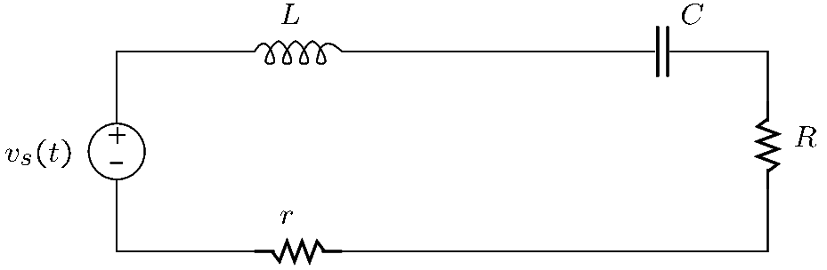
- Connect the following circuit. Using substituters, set $R=100 Ω$, $L=30$mH, and $C=100$nF.

- In this circuit, the load will consist of $R$ and $C$.
- Set the waveform generator to a sinusoidal signal of $5$V peak-to-peak and $600$ Hz.
- Create a LabVIEW virtual instrument that displays the average power and the graph of the instantaneous power of the load.
  - To determine instantaneous power, the instrument should measure the voltage on $r$, to determine the current. It should also measure the voltage on $R$.
  - The instrument should divide the voltage on $r$ by $r$ and then multiply the result by the voltage on $R$. The result of the multiplication is the instantaneous power. This should be averaged to find the average power.
  - The instrument should acquire data at a rate of 100,000 samples per second for 100 ms. The total number of samples in 100 ms will be _________.
- Adjust the value of the capacitor until the VI shows maximum power. This value should be between $100$nF and $2 μ$F. $C=$____________
- Measure the rms value of the capacitor voltage. $V_{C}=$_________
- Measure the rms value of the inductor voltage. $V_{L}=$_________
- Are the inductor and capacitor voltages equal? Should they be equal? ______________________________
- Adjust the value of the resistor $R$ until the VI reports maximum power. The optimal value should be between $10 Ω$ and $100 Ω$. $R=$_________
- Read the output resistance of the waveform generator from its front panel. $R_{out}=$______
- Does $R$ equal $R_{out}+r$? Should they be equal? _________________________________________________

