Interference Signals—Lab 11

M.V. Iordache, EEGR2051 Circuits and Measurements Lab, Fall 2020, LeTourneau University

See https://mviordache.name/EEGR2051 for more information.

Name______________________ Date__________ Section_____

EEGR 2051 – Interference Signals
Materials
- One NI Elvis.
- One Darlington npn transistor MJE800.
- Wire jumpers.

PROCEDURE
Capacitive Interference from Power Lines
- The following steps will demonstrate that capacitive coupling with the power lines creates voltage in an unshielded conductor.
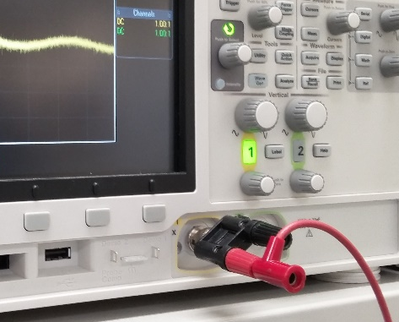
- Connect a BNC to double binding post adapter to CH1 of the oscilloscope.
- Connect a banana-to-banana cable to the signal terminal of the adapter as in the figure; do not connect anything to the GND terminal of the adapter.
- Set the horizontal control to $10 ms/div$.
- Adjust the vertical sensitivity of CH1 until a signal is clearly seen.
- To verify that you visualize an interference signal from the power lines:
  - Set the trigger source to Line.
  - Verify that the image is now stable.
  - Measure the frequency of the signal: ______________
- Disconnect the adapter from CH1. Is the signal still present? ___________
- Reconnect the adapter and the banana-to-banana cable to CH1.
- Verify that when you touch the free end of the cable the signal gets bigger.
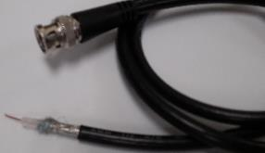
Shield
Signal conductor
Shielding
- Coaxial BNC-to-BNC cables have a conductive shield surrounding the signal conductor. This helps reducing interference. Note that the shield is connected to the ground terminal of the cable.
- Find a BNC-to-BNC cable.
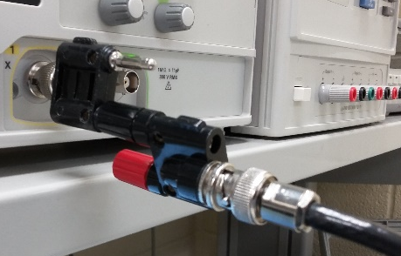
- In the following we will examine what happens when connecting only one of the conductors of the cable to the oscilloscope.
- First, we will measure the interference signal induced in the shield.
- Using adapters and if necessary, also short banana-to-banana cables, connect the ground terminal of the coaxial cable to the signal terminal of CH1 (see the figure). Do not connect the signal terminal of the cable!
- Without touching any cables, measure the peak-to-peak voltage on CH1: ____________
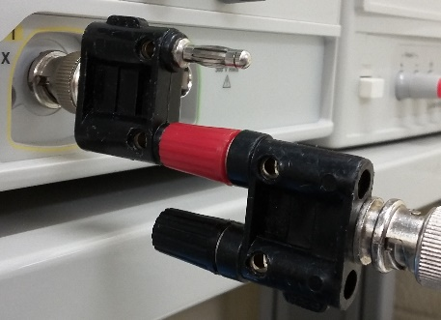
- Next, we will measure the interference signal induced in the signal conductor of the coaxial cable.
- Disconnect the ground terminal of the coaxial cable from the signal terminal of CH1.
- Without connecting the ground terminal of the cable to the oscilloscope, connect the signal terminal of the cable to the signal terminal of CH1.
- Without touching any cables, measure the peak-to-peak voltage on CH1: ___________
- The shield reduces the interference signal on the signal conductor. Is this fact confirmed by your measurements? __________
- The shield is most effective when connected to GND. To see this, connect directly the BNC connector of the cable to the BNC connector of the oscilloscope. This will also connect the shield to GND.
- Without touching any cables, measure the peak-to-peak voltage on CH1: ___________
- Is the interference signal eliminated? _______________________________________________

Capacitive Interference
- Set the waveform generator to a sine of 1 kHz.
- Adjust the amplitude of the sine to the maximum possible value.
  - The maximum value depends on the output load setting; possible maximum values include 10 $V_{pp}$ and 20 $V_{pp}$.
- Press the Trigger button of the oscilloscope and set source to CH1.
- The suggested time per division setting is $500 μs/div$.
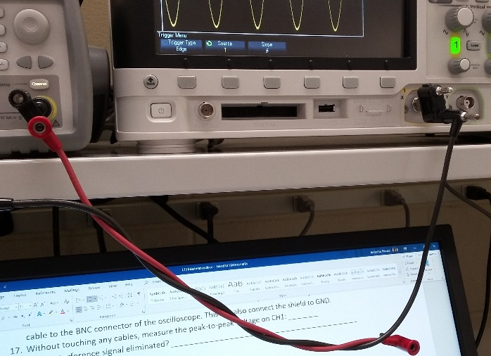
- Connect a banana-to-banana cable to the signal terminal of the waveform generator.
- Connect a banana-to-banana cable to the signal terminal of CH1 of the oscilloscope.
- Wrap one cable around the other. Three or four turns are enough.
- Without touching any cables, measure the peak-to-peak voltage on CH1. _______
- Does the CH1 voltage increase with frequency? ___________
- Why can inductive coupling be ignored in this setup? ________________________________

Inductive Interference
- Set the waveform generator to 500 kHz.
- The suggested time per division setting of the oscilloscope is $2 μs/div$.
- Connect the Sync connector of the waveform generator to the Trigger IN connector of the oscilloscope. This will ensure that the GND of the waveform generator is connected to earth ground.
- Connect a $47 Ω$ resistor between the terminals of the waveform generator.
- Find a banana-to-banana cable that is not already used in your circuit.
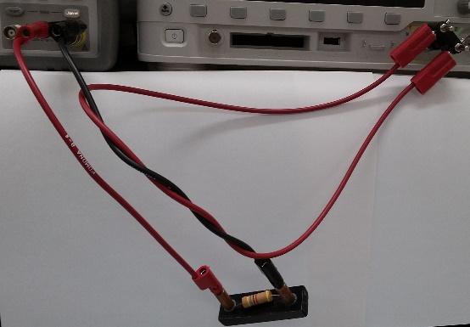
  - Wrap it around the cable that connects the $47 Ω$ resistor to the GND of the waveform generator. Three or four turns are enough.
  - Connect it between the two terminals of CH1 of the oscilloscope: one end of the cable should go to the signal terminal of CH1 and the other end to the GND.
- Without touching any cables, measure the peak-to-peak voltage on CH1. _______
- Does the voltage increase with frequency? ___________
- Why can capacitive coupling be ignored in this setup? ________________________________
- Do not disconnect the circuit; it will be used in the following LabVIEW exercise.
- LabVIEW can be used to control lab equipment and automate their measurements. In the following steps we will use a LabVIEW VI to obtain the graph of the inductive interference signal voltage versus frequency. Since the circuit operates at high frequency, the DAQ board is not appropriate for generating the analog signal. NI VISA drivers will be used instead to control the waveform generator and the oscilloscope via the USB ports.
- Download the file WGenOsc.vi from Canvas and open it.
- Open the front panel of WGenOsc.vi and locate the Oscilloscope (VISA name) control input.
  - From the drop-down list select the first device with the USB prefix.
  - If no USB device is listed, click refresh.
  - If no USB device is listed after refreshing the list, check that the oscilloscope is ON and that it is connected to the computer; the USB port on the rear panel should be connected to the computer.
- Locate the Waveform Generator (VISA name) control input.
  - From the drop-down list select the second device with the USB prefix.
  - If there is only one USB device listed, check that the waveform generator is ON and that it is connected to the computer; the USB port on the rear panel should be connected to the computer.
- Locate the amplitude and frequency controls on the front panel and set them to 10 V and 500 kHz, respectively.
- Locate the volts/div controls on the front panel and select 0.1 V/div on CH1.
- Press the Single Run button of the VI and verify that the VI displays a waveform.
  - If the VI reports an error, double-check that Oscilloscope (VISA name) selects the first USB device and Waveform Generator (VISA name) selects the second.
  - If the error persists, select the second USB device in Oscilloscope (VISA name) and the first USB device in Waveform Generator (VISA name).
  - An alternative way of determining the USB name of the waveform generator is by turning OFF the oscilloscope; the USB device that remains listed in the drop-down list corresponds to the generator.
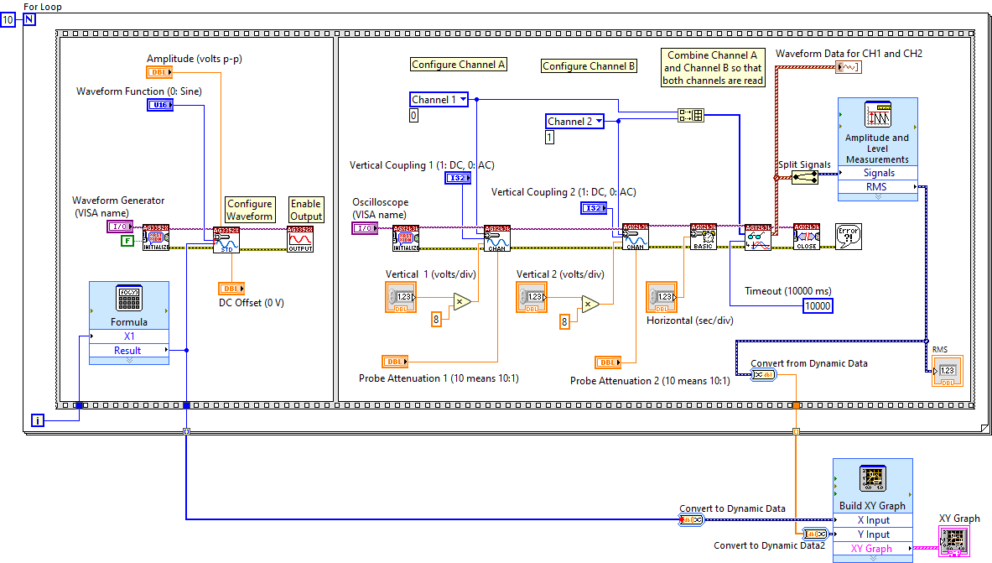
- Modify the VI to display the graph of the inductive interference voltage versus frequency.
  - The shown VI uses a Formula block to update the frequency of the waveform generator. The formula is 5E5 + X1*5E5 corresponding to a frequency range of 500 kHz to 5 MHz.
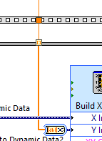
  - The XY Graph can be found in the Express palette of the front panel menu.
  - It is important to be attentive to wire thickness: a thin wire indicates a scalar; a thick wire indicates an array.
  - It is important to be attentive also to the tunnel mode. To output an array, right-click the tunnel and select Enable indexing.
  - When adding the Split Signals block, resize it so as to have two outputs. This will separate the data of CH1 from the data of CH2.
- If the VI works, the XY graph indicator will display a graph after the 10 iterations of the for loop.
- When testing the VI, look to the oscilloscope screen to ensure that the vertical range of CH1 is appropriate. For correct results, the oscilloscope must not clip the waveform.
- Adjust the vertical range so that the oscilloscope does not clip the waveform. The range should not be too big, or else the quantization error of the acquired waveforms will be quite large.
- Show the graph to the instructor.

Conductively Coupled Interference
- Disconnect the previous circuit.
- You may close the LabVIEW VI at this point. For the remaining part of the experiment, the waveform generator and the oscilloscope may be controlled directly from their front panels.
- Adjust the waveform generator to a rectangular waveform of 1% duty cycle and 2kHz frequency. The waveform should be varying between 0 and 5V. Indicate the parameters that should be used with the waveform generator:
  - Amplitude: _______ $V_{pp}$
  - Offset: _________V
- Visualize the waveform on the oscilloscope and record
  - The maximum value of the waveform: ________ V
  - The minimum value of the waveform: ________ V
- Turn ON the DC power supply.
  - Set the voltage limit to 5 V.
  - Set the current limit to 1 A.
- Connect the MJE800 transistor to a breadboard as follows.
  - Let GND denote the GND of the breadboard.
  - The minus terminal of the DC source should go to GND.
  - The collector of the transistor should go to the plus terminal of the DC source.
  - The emitter should go to GND.
  - The base should go to a $10 kΩ$ resistor.
  - Connect the other end of the resistor to the signal of the waveform generator.
  - Connect the GND of the waveform generator to the GND of the breadboard.
- Ideally, the voltage on the collector of the transistor should be _________.
- Visualize on CH2 the voltage of the waveform generator and on CH1 the voltage on the collector of the transistor. How does it differ from the ideal curve? __________________________________________
____________________________________________________________________________________
- Add a capacitor of sufficiently large value (above $1 μF$) between the collector and GND. How does the collector voltage change? ______________________________________________________________
____________________________________________________________________________________
- Visualize on CH1 the voltage between the emitter and GND.
  - The ideal value is: __________
  - The actual peak-to-peak value is: ____________

