Prototyping Electric Circuits—Lab 1

M.V. Iordache, EEGR2051 Circuits and Measurements Lab, Fall 2020, LeTourneau University

See https://mviordache.name/EEGR2051 for more information.

Safety
- All lab equipment is very safe. Nonetheless, be sure to follow the general safety rules below.
- Note that the variable isolated ac power supply (which is normally in the storage room) can generate large voltages. If you use it, avoid touching its terminals.
General Safety Rules
Note: This is not a comprehensive set of rules. Only rules that could be relevant for this lab were included.
- When the skin is wet, there are circumstances under which a voltage as low as 12 volts can be dangerous.
- Currents through your body should not exceed 5 mA. Working with circuits involving higher currents is not dangerous as long as voltages are low enough. The resistance of the body when the skin is wet could be as low as 1000 ohms; a 50V voltage would generate a 50 mA current!
- Do not handle electrical equipment when your skin is wet.
- In case of electric shock break the contact with the live conductor as soon as possible. The electrical resistance of the body decreases in time.
- Always wear shoes and keep shoes dry. Do not stand on metal or on a damp floor. Otherwise, electric currents can flow easily through your body to the ground.
- Shut off power before handling wires.
- Before replacing a fuse, turn off and disconnect the instrument from the wall outlet.
- Do not attempt to repair broken equipment. Ask the technician to repair it. If you are trained to repair electric equipment, remember that when “hot” equipment is repaired you should use only one hand, keeping the other hand far away from the circuit. This will only prevent currents from flowing from one hand to the other. Currents could still flow from one hand to the ground.
- Beware that DC voltage is more dangerous than AC voltage.
- Assume that all capacitors are charged.
- Replace damaged power cords.
- Use equipment with three-wire power cords.
- Do not work alone. If others are present they can help in case of accident.

First Aid for Electric Shock
- Shut off power immediately.
- If power cannot be turned off, break the contact of the victim using an insulator such as dry wood, rope, cloth, or leather. Avoid direct contact with the victim lest current flow from him through your body.

The rules above have been adapted from:
Electronic Instrumentation Laboratories, by S. Wolf and F. Smith
Introductory Circuit Analysis, by R. Boylestad
Disinfecting Technology
- Disinfect your hands before and after using the lab equipment.
- Do not disinfect the LCD screens of the instruments or of the computers; this could damage them. Disinfect your hands if you touch them.

Prototyping Electric Circuits

Objectives: Learn to use prototyping boards (aka breadboards).

Procedure:
- In the following steps you will verify that your kit includes a number of components that will be used in the following labs.
- Look up online the resistor color code. It can be used to read the values of resistors.
- Verify that your kit includes the following:
  - Resistors of 10, 100, 330, 470, 1k, 10k, 100k, and 1M ohms.
  - Potentiometers of 100 and 10k ohms.
  - Capacitors of 10n, 4.7$μ$, and 47$μ$ farads.
  - One 555 integrated circuit.
  - Two 2N3904 transistors.
  - Four LEDs.
  - One prototyping board.
  - One jumper wire kit.
  - One 9V battery.
  - 9V battery clips.
- The prototyping board is useful for creating quickly circuit connections without soldering the electronic components.
  - The vertical power rails and the rows are connected as shown in the figure.
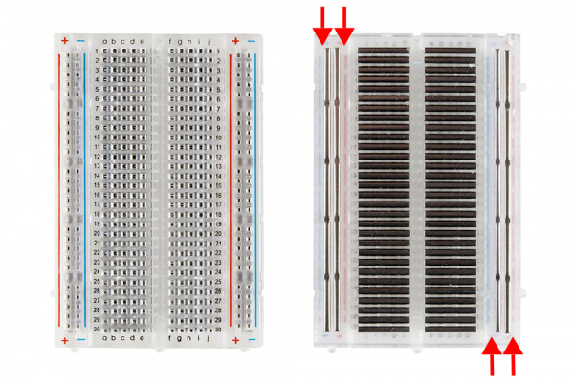
  - The power rails are meant for power connections.
A medium-size breadboard with the adhesive back removed to expose the power rails.
From https://learn.sparkfun.com/tutorials/how-to-use-a-breadboard/all, under the Creative Commons CC BY-SA 4.0 license.
- Connect the astable oscillator shown below. It corresponds to Figure 12 of the NA555 handout. The circuit should oscillate with a period of about one second.
  - Connect the 555 integrated circuit over the breadboard ravine.
  - The figure to the right shows how integrated circuit pins are counted.
  - Note that the polarized capacitor value is $4.7 μF$, not $47 μF$.
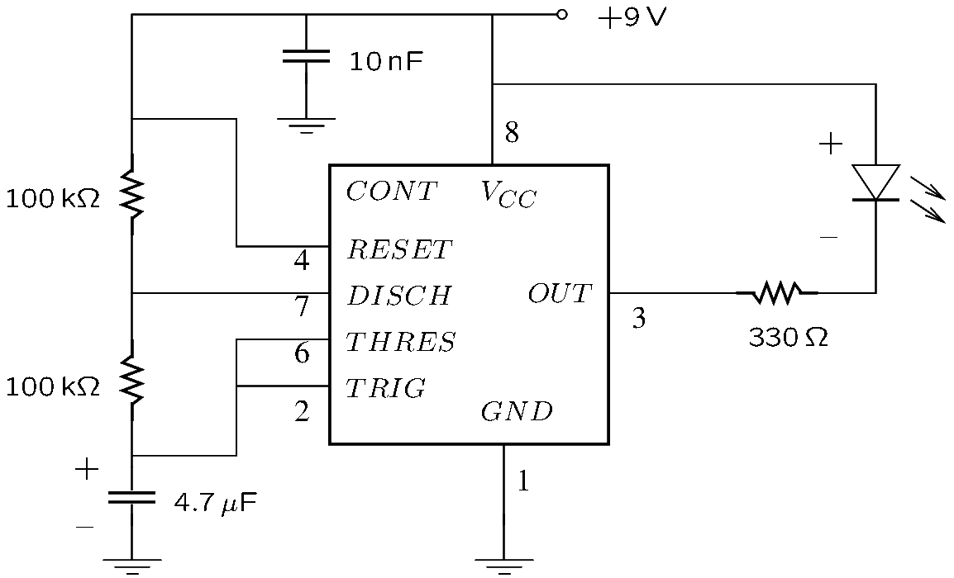
  - The ground symbol corresponds to the – terminal of the battery.
- Demonstrate your circuit to the instructor.
- Connect the monostable circuit below. It corresponds to Figure 9 from the NA555 handout.
  - Note that the value of the polarized capacitor is different now; it is $47 μF$, not $4.7 μF$.
  - Implement the switch with a long jumper wire that you manually connect or disconnect.
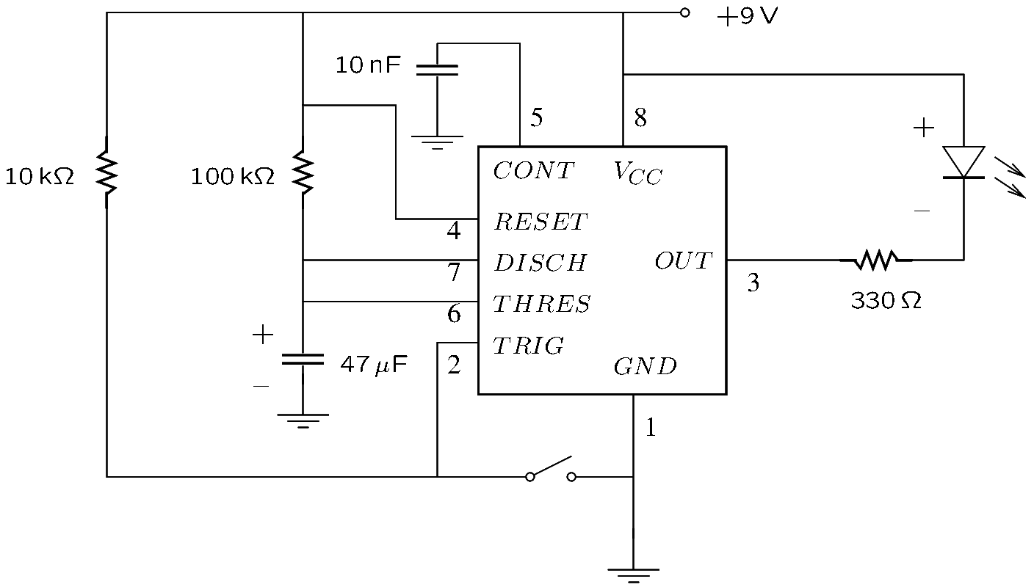
  - The switch will turn the LED off for at least 5 seconds. If the switch is closed for more than 5 seconds, the LED should turn on after the switch is opened. If the switch is closed for less than 5 seconds, the LED should remain off until the 5 second interval elapses.
- Demonstrate your circuit to the instructor.

